Resources on Asian and Pacific Island Catholics from the United States Conference of Catholic Bishops (USCCB)

Get your copy by contacting scapa@usccb.org. $4/copy, check pay to: Asian and Pacific Island Affairs. The USCCB Subcommittee on Asian and Pacific Island Affairs is actively working on having more books on other Asian and Pacific

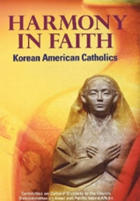

Harmony in Faith: Korean American Catholics

This small book on Korean American Catholics connects each believer to their roots in Korea, weaving through thick layers of their history of faith. By continuing the tradition of gathering as local faith communities characterized by sacrifice and adaptation, Korean American Catholics have emerged as part of the fabric of Church and society.

